Inclusive OER Course for Librarians

Participant Handbook

Table of contents

- Course overview
- Learning outcomes
- Weekly workflow and time commitment
- Participation requirements and assessment
- Module assignments and the final project
- Academic integrity and peer engagement
- Prior knowledge
- Technical considerations
- Accessing the learning platform
- Additional resources

This handbook gives you all the key information you’ll need as you move through the Inclusive OER Course for Librarians. Inside, you’ll find details about how the course is structured, how your participation will be assessed, what’s expected each week, and what kind of tech setup you’ll need. It’s here to support you throughout the course, feel free to refer to it whenever you need a refresher. This information will also be available via the learning platform.

1. Course overview
This course has been designed especially for you, African library professionals who are ready to lead the way in promoting inclusive, equitable access to knowledge through Open Educational Resources (OER).
Throughout the course, you’ll strengthen your understanding of OER and open licensing, and explore how these tools can support more accessible, relevant, and culturally responsive education in your community. The course aligns with UNESCO’s OER Recommendation, specifically Action Area 3, which focuses on ensuring effective and inclusive access to quality OER.
Along with your peers, you’ll engage with video lessons, readings, discussions and live sessions, all designed to accommodate your needs as a working professional. As you progress through each module, you’ll build a portfolio of work that contributes toward a final project you can apply directly in your own library setting.
By the end of the course, in addition to the new knowledge you’ve gained, you’ll also have access to a plan of action, practical tools, and a community of peers who are working towards the same goal: Open inclusive education for all.

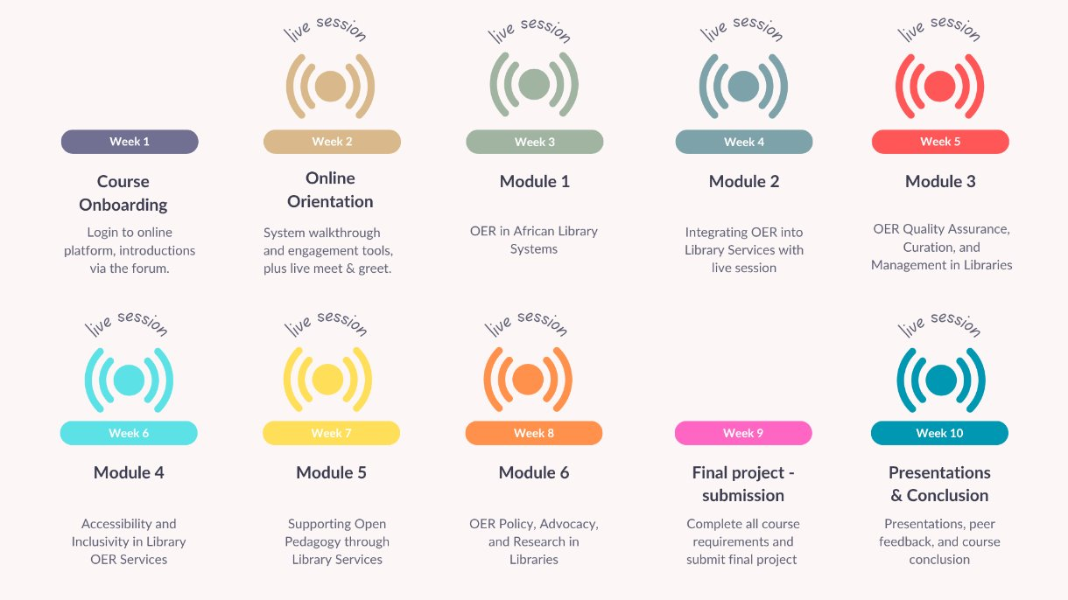
Figure 1: Course overview

2. Learning outcomes
Learning outcomes describe the knowledge, skills, and strategies you are expected to develop by the end of this course. They serve as a guide for your progress and are built into each module’s activities, gradually preparing you for your final assignment. These outcomes will help you track your growth as an OER practitioner while reflecting on the application of your learning week-by-week, in your own library context.

By the end of this course, you will be able to:
- Demonstrate a comprehensive understanding of the UNESCO OER Recommendation, particularly Action Area 3, and its application in African libraries.
- Source, retrieve, create, adapt, and share high-quality, culturally relevant and accessible OER using library specific processes and tools.
- Implement inclusive OER access strategies, including offline or low-connectivity solutions, tailored to your institutional setting.
- Design quality assurance mechanisms for OER appropriate to resource-constrained environments.
- Create an action plan for promoting and supporting inclusive and equitable access to quality OER, including collaboration with educators and institutions.
- Advocate for OER, contribute to policy development, and assess impact within your professional library context.

3. Weekly workflow and time commitment
This course is structured into six modules plus an Orientation Module, delivered over ten weeks. You’ll have access to the final assignment from the start of the course so you can plan and pace your work accordingly. A new module will be released every Thursday at 10:00 CAT, and your weekly assignments and activities will be due the following Wednesday at 23:00 CAT. You can check the course calendar on the learning platform for all important dates and deadlines.
Each module is divided into manageable lessons or units of work. We recommend that you follow the lessons in the order they appear. Each lesson introduces one or two key concepts and includes activities that encourage to apply or reflect on your learning right away. For the most effective learning experience, try to complete a lesson or unit of work in one sitting and aim to finish the module within the week. This will help you take part meaningfully in the weekly forum discussions and stay connected in the informal WhatsApp chats.
On average, you can expect to spend 5–8 hours per week on core course content. Refer to Figure 2 for a visual guide to the estimated learning times.

Figure 2: Notional hours per week

To help you plan your time and stay on track, refer to Figure 3 (below) to get an idea of what you can expect each week.
Figure 3: Course – Weekly breakdown of activities

Note: You may find that a module takes you less or more time than indicated. These figures are only estimates, and each participant may work at a different pace.

4. Participation requirements and assessment
You will need to achieve an overall mark of 50% across all activities to pass this course.

If you complete all the course requirements, as shown in Figure 4, you’ll receive a certificate of completion. If your final grade is above 70%, you’ll be awarded a certificate of excellence. Please note that certificates can only be issued if all required activities are completed.

Your final grade will be based on your participation in the following components:
- Module assignments: You will submit project work for Modules 1–6, which will be peer assessed. Peer reviewers will use a grading rubric to provide feedback and allocate marks. Results will be shared one week after the submission deadline. Some modules may include more than one assignment. Each module carries a weight of 11% with a total of 66% across all modules. The final project, which will be assessed in the same way, is due in Week 9, and carries a weight of 20%.
- Small group discussions: Active participation in the discussion forums for the Orientation Module and Modules 1–6 counts towards your final grade. Each module is worth 1%, for a total of 7% of your final grade. Some modules may include more than one discussion. To receive the full percentage point for that module, you must contribute meaningfully to all discussions. A post can either respond to the discussion prompt or to another participant’s post. Each discussion will remain open for one week after the module is released, be sure to contribute while the topic is hot and before the deadline.
- Peer grading participation: Peer grading also counts towards your final grade. You are expected to assess your peers’ assignment submissions during Modules 1–6, as well as the final project. This participation is worth an additional 7% of your final grade (1% per module and 1% for the project).
- Other activities: Participation in the WhatsApp group and broader class-wide discussions is highly encouraged but not graded. Personal journals and quizzes and activities embedded within lessons are also not graded but are valuable for your own learning.

Small group discussions are a great opportunity to explore complex ideas, test your understanding, and learn from your peers. They’re also a step towards building a sustainable community of practice beyond this course.

Figure 4: Grade weighting and distribution across activities

5. Module assignments and the final project
As part of this course, you’ll complete one or more assignments for each module. You’ll also have opportunities to test your knowledge through quizzes, explore key themes through forum discussions and short activities, and capture your thoughts using guided journal templates. These journal entries can support your final project, helping you track your learning as you go

Refer to Figure 5 below for a breakdown of what’s expected in each module and where you’ll earn grades.

Alongside your weekly tasks, you’ll work towards a final project that brings together your learning and allows you apply it in a way that’s meaningful to your own library context. Early in the course, you’ll choose one of three options:
- A comprehensive OER strategy for your library,
- A focused action plan and advocacy pitch,
- A practical challenge-solution initiative to address a specific barrier to OER adoption.​

Each project is designed to support the practical application of what you will learn throughout the course, whether that’s policy development, inclusive practices, curation, or open pedagogy, drawing on insights from your assignments, discussion forums and live sessions. Once you’ve selected a final project, you’re encouraged to use it as a guiding lens for your work: shaping your assignments, reflections, and discussions in ways that will strengthen and enrich your final submission.​
​
While the project is only due in Week 9, you’ll have access to all instructions and templates from the start, allowing you to plan ahead and build towards your final project week-on-week.

You can find a detailed final assignment brief in Participant Handbook pack on the learning platform.

# | Type | Activity summary | Graded Y/N | Potential % if all complete
O1.1 | Forum | Introduce yourself via the forum using a video or written paragraph. | Y | 1.00
O1.2 | Quiz | Answer the multiple choice questions to test your knowledge on Open Licences | N | 0.00
M1.1 | Forum | Provide context about where you | Y | 1.00
M1.2 | Journal | Have you had to advocate for a new resource, service or idea? What worked? What was challenging? | N | 0.00
M1.3 | Journal / Forum | Read the case studies, then use the journal template to organize your thoughts and finally follow up by participating in the forum discussion. | Y | 0.00
M1.4 | Assignment | Six tasks are available as part of this assignment. Complete the one that has been assigned to your group. | Y | 11.00
M1.5 | Peer grading | Use the rubric as a guide to grade the assignment/s that has been allocated to you. | Y | 1.00
M2.1 | Forum | Use the prompts provided to describe your own context and participate in the forum discussion. | Y | 1.00
M2.2 | Journal | Make a note about which roles you play in your library and which roles you'd like to develop. | N | 0.00
M2.3 | Activity | Use Chat GPT and this prompt to search for OER that are freely available, openly licensed, and relevant to your subject and region. | N | 0.00
M2.4 | Journal | Reflect on the video provided and following the prompts jot down your thoughts in the template provided. | N | 0.00
M2.5 | Assignment | Design a workshop that supports OER integration in diverse African library contexts. | Y | 11.00
M2.6 | Peer grading | Use the rubric as a guide to grade the assignment/s that has been allocated to you. | Y | 1.00
M3.1 | Forum | Discuss how poor curation and lack of quality control in OER can impact your library community. | Y | 1.00
M3.2 | Assignment 1 | Create your own OER quality assurance framework. | Y | 5.50
M3.3 | Activity | Match the librarian's role in OER curation with the description of what it involves. | N | 0.00
M3.4 | Assignment 2 | Build your own OER collection using an online platform or a spreadsheet. | Y | 5.50
M3.5 | Peer grading | Use the rubric as a guide to grade the assignment/s that have been allocated to you. | Y | 1.00
M4.1 | Forum | Reflect on a time you engaged with an OER or digital resources and discuss its accessibility and inclusivity for diverse users. | Y | 0.50
M4.2 | WhatsApp | Explore a physical space in your library or institution and reflect on how inclusive and accessible it is. | N | 0.00
M4.3 | Quiz | Check your learning by completing this multiple choice quiz. | N | 0.00
M4.4 | Forum / Journal | Reflect on how UDL applies to your library context, discuss potential challenges, and suggest practical solutions. Add your notes to the forum template provided. | Y | 0.50
M4.5 | Assignment | Find and adapt an openly license resource that does not fully align with UDL principles and/or WCA Guidelines. Document the process. | Y | 11.00
M4.6 | Peer grading | Use the rubric as a guide to grade the assignment/s that have been allocated to you. | Y | 1.00
M5.1 | Forum | Share your thoughts as they relate to the quote provided. | Y | 0.25
M5.2 | Forum | Answer the questions to describe Open Pedagogy in action within your context | Y | 0.25
M5.3 | Activity | Match each attribute of Open Pedagogy with a real-world example. | N | 0.00
M5.4 | Forum | Choose one of the scenarios outlined and share your thoughts about it in the forum. | Y | 0.25
M5.5 | Forum | Thinking about publishing and supporting open knowledge, answer these questions in the forum. | Y | 0.25
M5.6 | Assignment | Contribute to Open Cultural Heritage either by digitizing local heritage or creating an openly licensed resource. | Y | 11.00
M5.7 | Peer grading | Use the rubric as a guide to grade the assignment/s that have been allocated to you. | Y | 1.00
M6.1 | Forum | Begin building a case for OER adoption in your institution. | Y | 0.50
M6.2 | Assignment 1 | Develop a policy statement and explain what role librarians can play in supporting the policy's implementation. | Y | 3.66
M6.3 | Forum | Answer the questions in the forum to guide you on your way to developing an advocacy action plan to promote OER adoption. | Y | 0.50
M6.4 | Assignment 2 | Using the template provided, create an OER advocacy action plan. | Y | 3.67
M6.5 | Assignment 3 | Document your approach to assisting a researcher in sharing their work. | Y | 3.67
M6.6 | Peer grading | Use the rubric as a guide to grade the assignment/s that have been allocated to you. | Y | 1.00
F1 | Final Project | Select one of three final project options available to you and complete it using the template provided. | Y | 20.00
F2 | Peer grading | Use the rubric as a guide to grade the final projects that have been allocated to you. | Y | 1.00
 |  | Total grades
 |  | Total grades available: |  | 100.00

Figure 5: Weekly assignment and grade breakdown

6. Academic integrity and peer engagement
All participants are expected to uphold the values of honesty, integrity, and mutual respect throughout the course.

Please review your peers’ submissions thoughtfully, using the grading rubrics provided as your guide. Aim to offer constructive feedback that is fair, encouraging, and rooted in the principles of learning together. Your comments should help your peers reflect, improve, and feel motivated to continue. Timely participation in the peer grading process is also part of the commitment you make when enrolling in this course. It ensures that everyone receives feedback when they need it, and it contributes to a strong and supportive learning cohort.

If at any point you feel that you have been graded unfairly, or you are unhappy with the grade you receive, you may lodge a query with the course facilitator. The facilitator will engage you in a formal procedure to address your grading concerns. However, please note that your work will continue to be reviewed from a peer-to-peer perspective; you will not be able to request that your work is re-graded by a facilitator or assessed in a different way. Once the formal procedure is complete, the final grade will stand, and no further discussion will be entered into. Finally, remember that peer grading is not just about awarding marks. It’s a chance to learn from one another, build confidence, and strengthen our community of practice.

To help maintain academic standards, some assignments may be randomly reviewed using plagiarism detection tools. These compare your submission against academic databases and online sources to support fairness and ensure originality.

7. Prior knowledge
To get the most out of this course, you should already have a basic knowledge OER and related open practices. This is not a foundational course; if you are new to OER or feel unsure about your understanding of the basics, we recommend that you first complete one of the introductory courses listed in the course resource list. Once you’re confident in your ability to find, evaluate, and adapt OER—and understand key concepts like Creative Commons licensing and Open Access—you’ll be well prepared to engage with this course. ​

It’s especially important that you are familiar with: ​
- OER Search​
- OER Evaluation​
- Techniques for adapting OER ​
- Understanding and applying Creative Commons Licenses​
- Generating a Creative Commons license​
- Concepts of Open Education, Open Resources, Open Access Journals, and Open data.

8. Technical considerations
To participate fully in this course, it’s important that you meet the minimum technology requirements. These ensure you can access materials, take part in live sessions, and complete assignments without unnecessary difficulty. ​

You will need: ​
- A digital device (such as a computer, laptop, or tablet)​
- Reliable internet connectivity​
- Access to Microsoft Teams or Zoom for live sessions​
- Basic knowledge of word processing (e.g., editing documents, saving files, copying and pasting.)​
- Familiarity with using WhatsApp for communication and updates​

9. Accessing the learning platform

The learning platform is accessible at the following URL: (TBC)

This URL will also be sent to you via email along with your username and password. Please complete your profile on the learning platform so that when your certificate is issued your name and surname are printed in the correct order and with the right spelling.

If you require a PDF version of the course or have accessibility requirements that need to be addressed, please consult with the course facilitator to make these materials and other support mechanisms available to you.

10. Additional resources
If you would like to do additional reading to complement your learning in each module, you can access a dynamic list of selected resources via the learning platform under the “Additional resources” menu item.

